Scaling private-sector-led solar-powered Irrigation Systems (SPIS) for climate-resilience in smallholder farming in Sub-Saharan Africa
- Description of the innovation package
The core innovation of this scaling track is a bundled solar-powered irrigation system (SPIS) scaling package consisting of solar-powered irrigation pumps (validated, market-ready), financial innovations (e.g., PayGo/PayOwn models and blended finance, i.e., to de-risk investments using public or philanthropic funds in the long term), context-specific public-private partnership, and capacity building (e.g., extension workers and private sector partners) to reduce transaction costs and create incentive mechanisms for SPIS adoption by smallholders.
While PayGo/PayOwn and blended finance mechanisms are central to the Inclusive Scaling Pathway developed under S4I (eg. for Ethiopia https://hdl.handle.net/10568/180367 ), this track remains flexible and responsive to country-specific conditions. It actively explores complementary financial instruments aligned with local demand patterns, risk profiles, and technology supply chains. This ensures that financing solutions remain relevant and scalable across diverse institutional and market environments.
SPIS is already scaling-ready and validated in real-world conditions, as demonstrated in Sustainable Finance for Off-Grid Solar Irrigation: IPSR Innovation Profile, Solar Irrigation Pump (SIP) Sizing Tool: IPSR Innovation Profile, and Irrigation for smallholder farmers | CGIAR System. The track, however, goes beyond SPIS to promote farmer-led irrigation (eg, efficient fuel pumps, hybrid systems, and improved agronomic practices) that enhance water productivity and system efficiency. S4I leverages the Solar phase II bilateral project to assess the suitability of SPIS and pump sizing in target countries. Such digital tools (eg., Solar irrigation potential explorer_poly vr1) can also support capacity building in S4I.
Evidence from Nigeria, Ethiopia, Kenya, and South Asia consistently shows that SPIS is financially compelling when properly packaged. In Nigeria, SPIS investments for crops such as tomatoes, red peppers, onions, and rice have yielded very high returns, and SPIS has co-designed a scaling pathway with the Bank of Agriculture (BoA). In Ethiopia, SPIS is officially tax-exempt, benefit–cost ratios exceed one (https://doi.org/10.3390/su17041486). In Kenya, IWMI and SunCulture co-designed a water strategy that aligns SunCulture’s solar-scaling operations with environmental sustainability goals. Farmers are not adopting primarily because of financial barriers; they adopt because it reduces energy costs relative to fuel, provides access to water, increases yields, and stabilizes incomes. This package reduces investment risks, lowers upfront costs, and ensures sustainable groundwater use.
- Scaling ambition (2026–2028)
By the end of 2026, our target is to reach 130,000 farmers (Table 1) through engaging with relevant intermediary actors along the irrigation supply chain including private technology suppliers, financial institutions, and government agencies, and bridging the gaps by facilitating investment in new solar technology units, enhancing capacity utilization of underutilized existing infrastructure and digital tools, capacity strengthening for increased efficiency, and providing enabling institutional environment. We aim:
- 15,000 farmers reached through deployment of SPIS by public and private partners,
- 1 curriculum in Kenya and 2 training materials in Ethiopia and Nigeria developed and identified to reach 10000 farmers through capacity building for FLID investment and upgrading by smallholder farmers,
- 02 appropriate finance facility in Nigeria and Kenya, which is projected to directly benefit 7000 smallholder farmers who invest in SPIS and FLID,
- 03 formal/informal PPPs in Ethiopia, Nigeria, and Kenya developed that provide extension and agronomic support, which is projected to directly benefit 100000 smallholder farmers who invest in SPIS and FLID.
- 1 policy brief in Ethiopia and 1 policy brief in Nigeria (in collaboration with Climate Action) that impacts Solar and FLID investments in 2027 and 2028
Table 1: Country breakdown (based on partner capacity and pipelines) for 2026, 2027 and 2028 (see the details in the Excel)
 | 2026 |  |  | 2027 | 2028
Farmers reached by | Ethiopia | Nigeria | Kenya
SPIS deployment by the public and private | 528 | 10050 | 5000 | 17135 | 18849
Capacity building on solar and FLID (use of digital tools and curriculum) | 468 | 4000 | 5000 | 10915 | 12606
Extension and agronomic support | 50000 | 20000 | 30000 | 108000 | 122400
Finance access and policy support | 300 | 5000 | 2000 | 60230 | 61293
Total | 51296 | 39050 | 42000
 | 140,770 |  |  | 196280 | 215,149
By 2028, we aim to reach a cumulative total of 540,000 farmers through technical assistance for the deployment/establishment of more than 50,000 SPIS by public and private partners, provide capacity building through formal curriculum and trainings on digital tools to improve investment by more than 33000 farmers, more than 128,000 farmers reached through financial facility and policy support and more than three PPPs that provide extension and agronomic support, which is projected to directly benefit a cumulative of more 330,000 smallholder farmers who invest in SPIS and FLID. Targets are based on national strategies, partner commitments, and their annual plans in irrigation development.
- Key demand and scaling partners
Demand for SPIS and FLID comes from governments seeking a PPP strategy (e.g., by MoA in Ethiopia), climate-resilient irrigation pathways (e.g., NEMA in Kenya), scalable markets by private suppliers (e.g., SunCulture in Kenya), and de-risked investment opportunities by financial institutions (e.g., BoA in Nigeria). We identified key partners with whom we will work to achieve the targets; some will be funded by the S4I program. They were identified and selected because they have already worked with IWMI and IFPRI, have demonstrated reach and credibility, and were active in the 2025 S4I activities. In Nigeria, the Ministry of Agriculture and Food Security (MoU with IFPRI) serves as the policy anchor; CeeSolar leads market-based delivery of solar solutions; the Bank of Agriculture (MoU with IWMI) provides financing and scaling; Ahmadu Bello University and Aliko Dangote University of Science and Technology support technical validation and training; and National Agricultural Extension and Research Liaison Services (NAERLS) in Nigeria drives awareness and farmer outreach. In Ethiopia, the Ministry of Agriculture and MILLS anchor policy and extension; Green Scene Energy (MoU with IWMI) leads market-based supply and scaling; and Lewegen MFI supports farmer finance. In Kenya, SDI (MoU with IWMI), NIA, and NEMA (MoU with IWMI) provide policy leadership; SunCulture leads solar technology supply; Strathmore University supports technical validation and capacity building; and GOGLA coordinates industry engagement, with KCB and Equity banks supporting farmer finance. The S4I team will work with partners through technical assistance on technology types, market segmentation, farmer organization, de-risking investments, and co-designing loan products and scaling pathways.
- Scaling Pathways
Scaling of primarily SPIS and other FLID bundles is underway in Nigeria (Kebbi, Kano, and Kaduna states), Ethiopia (Rift Valley, central Ethiopia, and southern Ethiopia regions), and Kenya (Eastern Province, Rift Valley, and Western Province) due to strong demand, policy readiness, and growing markets for (solar-powered) FLID. The last-mile delivery relies on private-sector-led delivery, financial innovation designed for SPIS/FLID (PayGo, PayOwn, and blended finance), extension and agronomic support, and capacity building through PPP (Figure 1). S4I leverages bilateral projects for digital services for suitability, pump sizing, and south-south leanings. S4I funding will be used to provide technical assistance, build partnerships, and deploy scaling pathways. This solution track contributes to the AoW 3 of S4I in Kenya, which leads the design of appropriate financial products (loan products, credit arrangements, insurance mechanisms, risk sharing, or de-risking), and IFPRI leads in Nigeria to align the demand and supply of financial services. This needs to account for country contexts (Kenya and Nigeria).
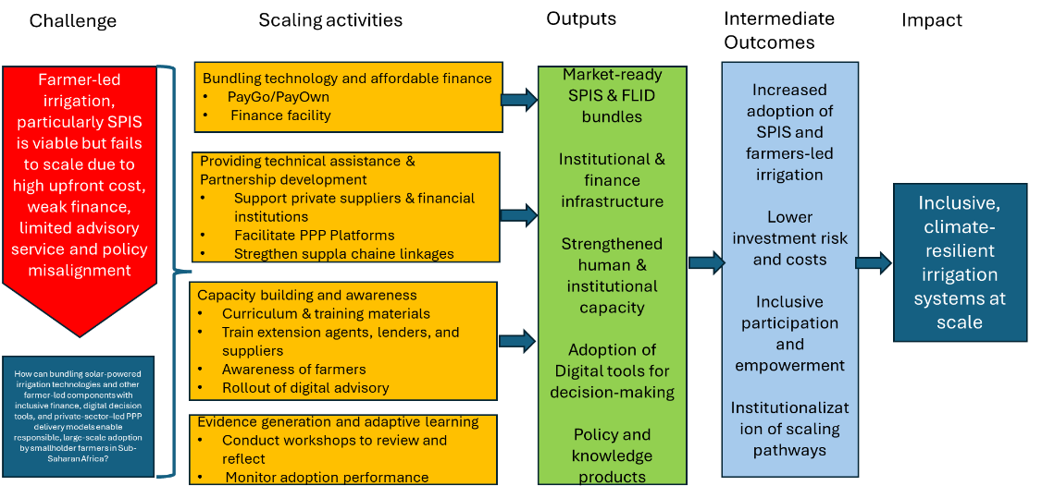
Figure 1. Theory of scaling and changes
We chose this pathway because evidence shows that financial innovations with established partnerships among public and private approaches outperform traditional commercial finance in terms of durability and scale. At the same time, our approach is flexible: we can pivot between solar-powered and farmer-led irrigation by targeting individual-farmer models, cooperatives, or irrigation-as-a-service (provided by private institutions or resource-owned farmers), depending on local conditions.
Our theory of change is clear. If solar irrigation technologies and farmer-led irrigation are bundled with affordable finance, digital decision tools, strong private delivery systems, and supportive policies, then adoption barriers fall, markets function more effectively, and farmers adopt at scale.
- Scaling track implementation plan (2026–2028)

Table 2 presents a milestone-based scaling roadmap for 2026–2028, linking quarterly implementation actions to measurable evidence and adaptive decision points. It shows scaling milestones, decision points, and adaptive management needed, and the systematic collection of evidence. It links implementation actions to measurable outcomes and adaptive learning mechanisms, enabling timely monitoring, reflection, and course correction to ensure the solution track remains on course to achieve its ambitions.

Table 2. Milestone-based scaling roadmap for 2026–2028
Year | Scaling milestones | Key implementation actions | Evidence and data outputs | Adaptive learning and management

2026
Q1 | Country pipelines validated | - Confirm scaling and institutional partnership plans (workshops)  - Identify and agree on key technical/institutional support needed with each partner  - South-south learning meetings (bilateral)  - Assessment of finance/policy landscape assessment (IFPRI in Nigeria)  - Discuss key learning questions | - Updated agreed action plan (activities and timeline)  - Partner targets by country  - Baseline adoption data  - List of support types  - Policy landscape  - Finance diagnostics | - Review partners' readiness and finance diagnostics.  - Validate priority regions and delivery partners  - Document risks and assumptions  - Refine country action plans and support
Q2 | Scaling pathways operationalized by farmers, public institutions, and private partners through targeted capacity building and awareness programs | - Training material identified/developed  - Engage with financial institutions and technology suppliers to roll out technology scaling (IFPRI in Nigeria)  - Farmer awareness campaigns on finance and ownership models  - Initiate formal and informal PPP (IFPRI in Nigeria)  - Digital tool training (IFPRI in Nigeria) | - Training completion records  - Pre/post knowledge assessments  - Scaling approaches  - Farmer uptake intentions  - Feedback for adaptive learning | - Analyze pre- and post- training and partner feedback  - Identify gaps in institutional and farmers' understanding of scaling pathways  - Adapt training content, delivery methods and awareness strategies  - Adjust partnerships and PPP arrangements
Q3 | Early scaling proof achieved | - Training and awareness through the media houses  - Rollout digital advisory (contribution from IFPRI in Nigeria)  - Define financial facility (contribution from IFPRI in Nigeria)  - Mid-year reflection workshop (½ day adaptive learning) | - Adoption rates ≥ 40% of targeted farmers.  - Irrigated areas data  - Gender disaggregated participation rates  - Youth participation | - Review mid-year performance data  - Assess the effectiveness of the finance mechanisms and advisory services  - Identify bottlenecks and successful practices  - Rebalance delivery
Q4 | Expand outreach, strengthen partners' engagement, and lessons for policy | - Training and awareness through the media houses  - Initiate formal and informal PPP  - Policy briefs  - Annual learning workshop (adaptive learning)  - Plan for 2027 | - Adoption rate reach 100% of targeted farmers  - Finance transactions | - Synthesize annual learning  - Evaluate partners' performance  - Integrate lessons into revised scaling pathways  - Confirm 2027 priorities and resource allocations

2027
Q1-2 | Finance and delivery systems scaled | - New regions identified  - Extension and agronomic support through training and capacity building (IFPRI in Nigeria)  - Expand finance facilities and access (IFPRI in Nigeria)  - Private supplier expansion  - New PPP establishments | - Adoption rates reach ≥ 40% of targeted farmers.  - Training completion  - New partners' growth data,  - Cost reductions | - Review performance  - Assess institutional capacity  - Adjust risk-sharing mechanisms  - Prioritize high-performing partners and regions
Q3-4 | 2027 scaling targets verified, finance facility establishment in two countries, and regional replication initiated | - New region entry in each country  - Re-define the scaling pathways  - Service-model pilots  - Cross-country learning | - Adoption rates reach 100% of targeted farmers  - Finance transaction  - Comparative performance data  - Service viability | - Compare performance across countries  - Evaluate finance facility viability  - Identify dominant pathway

2028
Q1-2 | System-level integration and implementation of scaling | - Embed in national programs  - Budget alignment  - Regulatory support | - Adoption rates reach ≥ 40% of targeted farmers  - Policy uptake evidence  - Public finance leverage  - Verified farmers reached | - Assess alignment with national policies, budgets, and regulatory framework
Q3-4 | Sustainable scaling consolidated | - Private-led expansion  - Exit from intensive support  - Final impact review | - Adoption rate reach 100% of targeted farmers  - Long-term adoption trends  - Environmental indicators  - Investment leverage | - Conduct final impact assessment  - Evaluate transferable lessons
- Complementary bilateral projects and S4I additionality
S4I resources strategically leverage ongoing bilateral initiatives to enhance scalability, coordination, and long-term sustainability. The SoLAR Phase II project provides systems-level support for solar agriculture in Ethiopia and Kenya, NSSID strengthens piloting and policy integration in Ethiopia, and the IFPRI-led Irrigation Investment Tool informs investment decisions in Nigeria. Building on these platforms, S4I adds value by consolidating 2025 outcomes and bundling solar and farmer-led irrigation technologies with inclusive finance, digital advisory tools (i.e., developed through bilaterals projects), and institutional capacity development. S4I funding supports key intermediaries that link farmers to financial institutions, reducing risk and improving access to credit.

